Mohamad Hamdanieh

Beyrouth , Lebanon | mohamadhamdanieh9@gmail.com | +961 81 400 387

1. Objective

Passionate and self-taught web developer with 2 years of experience in HTML, CSS, and JavaScript. Seeking to leverage my technical skills to create user-friendly and efficient websites.

1. Skills:

- HTML

- CSS

- JavaScript

-Python

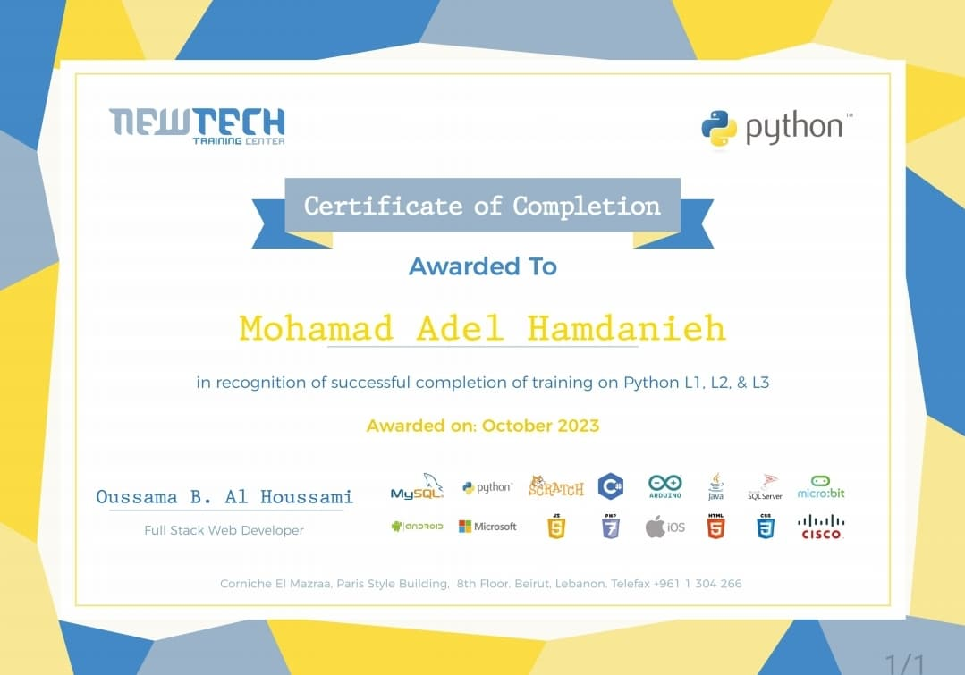

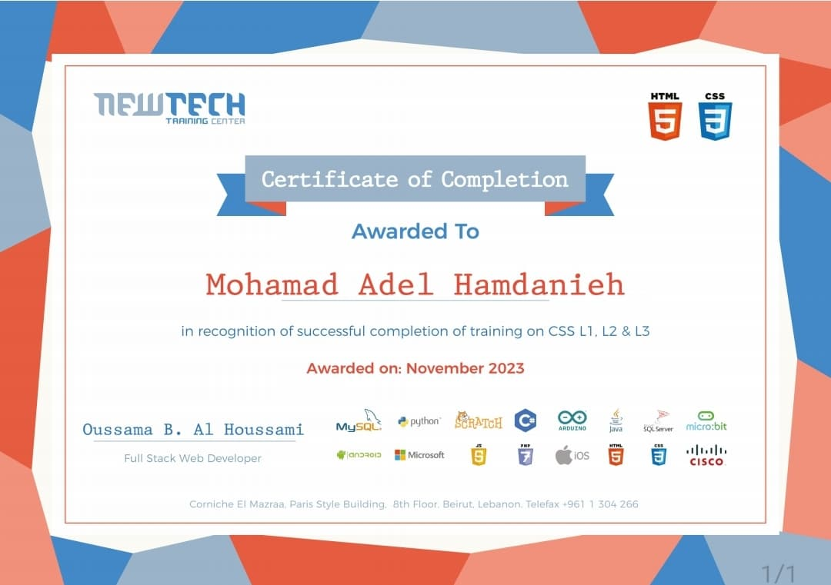

1. Freelance Web Developer (2022 - 2024)

- Developed and designed various websites using HTML, CSS, and JavaScript.

- Debugged and fixed issues to improve website performance.

1. Education

Collège du Sacré-Coeur (2021 - 2024)

1. Personal Projects

Flash-Cards:

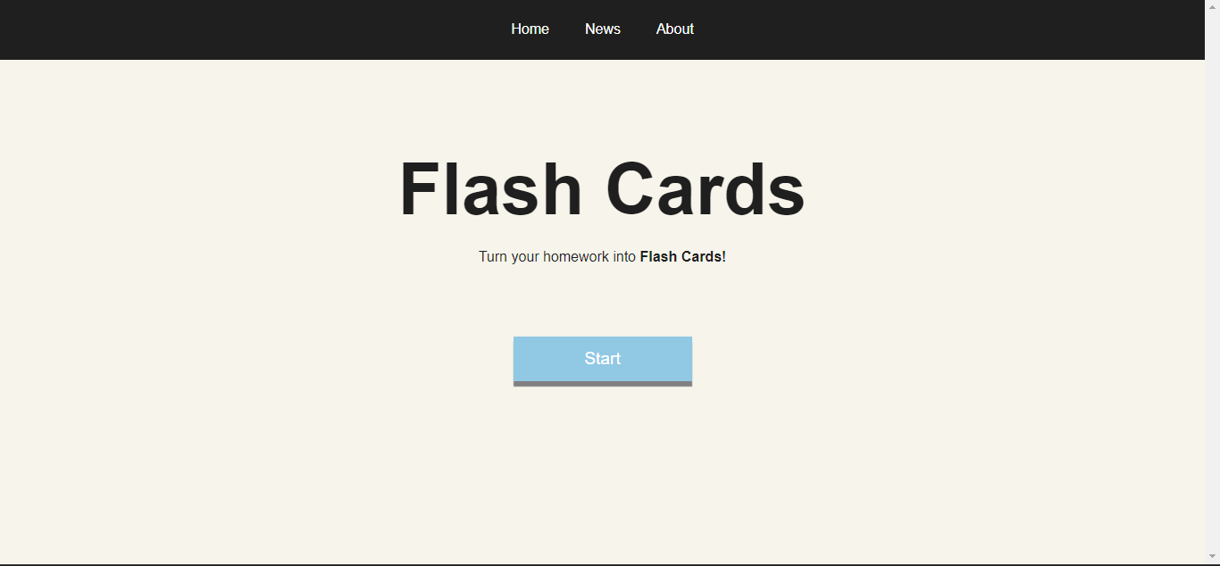

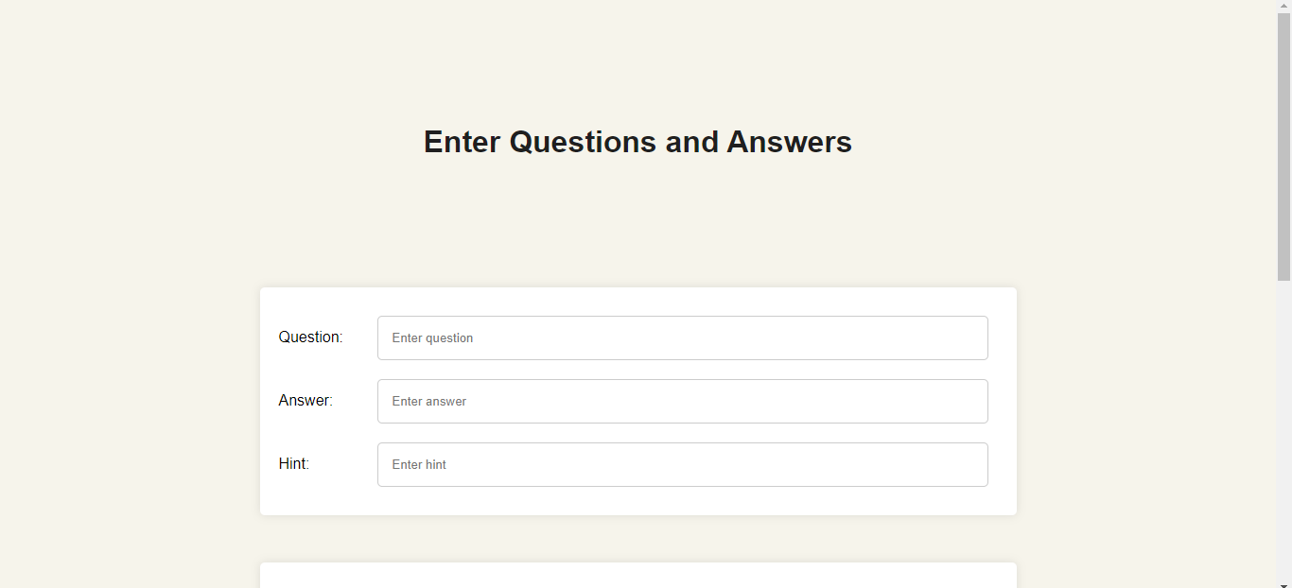

MoodTube:

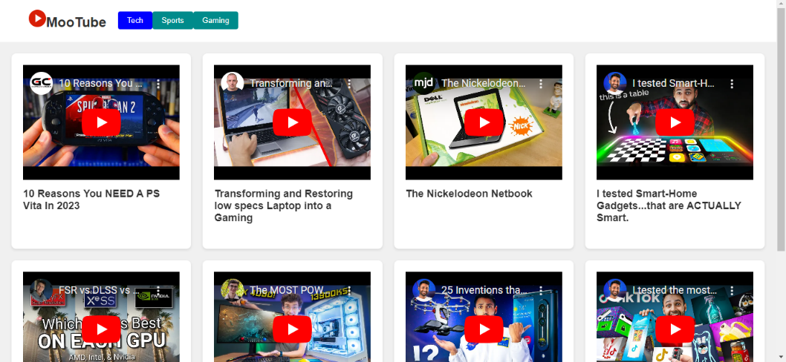

Mood Cinemas:

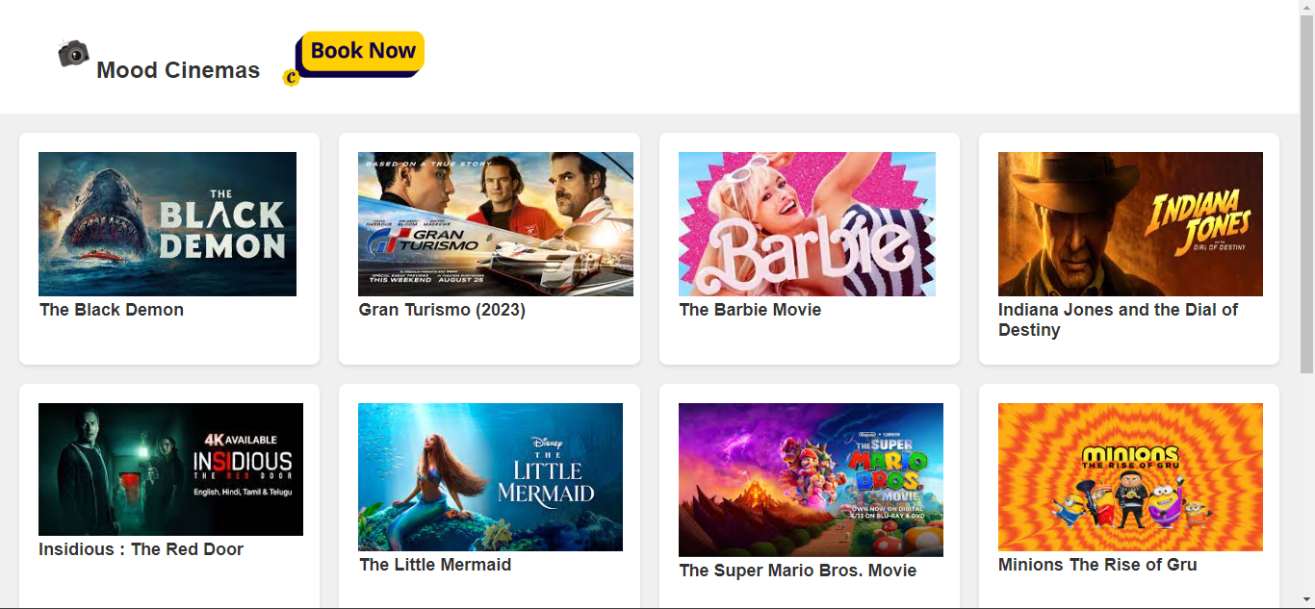

1. Languages

English , Arabic , French

1. Interests

Technology and AI , Basketball , Video-games